FINAL LAB TASK
Submitted by: BISMA KHAN
Seat No: B18158008
Course Incharge: MISS FARZEEN ASHFAQ
Course Title: TOCI II (DEEP LEARNING)

Pothole Detection using yolov5l
INTRODUCTION
Potholes are important clues that indicate the structural defects of the asphalt road, and accurately detecting these potholes is an important task in determining the proper strategies of asphalt-surfaced pavement maintenance and rehabilitation.
This issue is mainly affecting our city for a very long period of time. Many of us suffer alot when there is heavy rain or drainage. By detecting potholes all over the city we can take essential steps forward (like automatic detectors, sensors, etc) to control the situation.

DATASET
I have used a dataset of POTHOLE images downloaded from ***Roboflow***. The dataset contains a total of 665 images (not a large dataset but can be used as an initital step) and partitioned as
- Train Images: 465
- Test Images: 133
- Validation Images: 67
Pothole Images Dataset Link

MODEL
I have used YOLOV5l for this problem. Yolov5 has significantly reduces the time required for training the model and also improves the accuracy. The reason why I chose Yolov5l amongst 5x, 5s, etc can be well understood by this graph
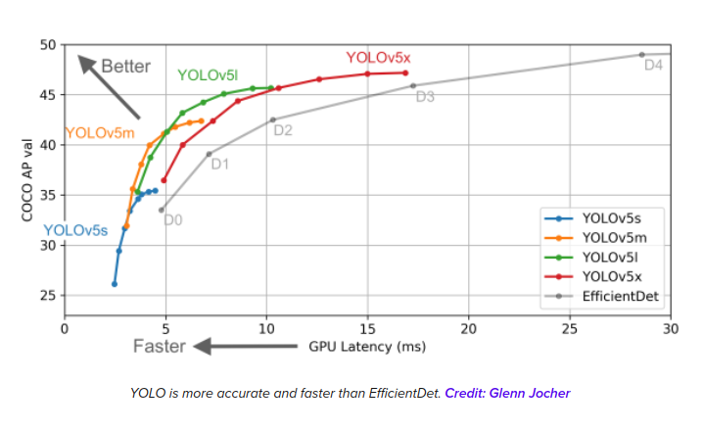
PERFORMANCE
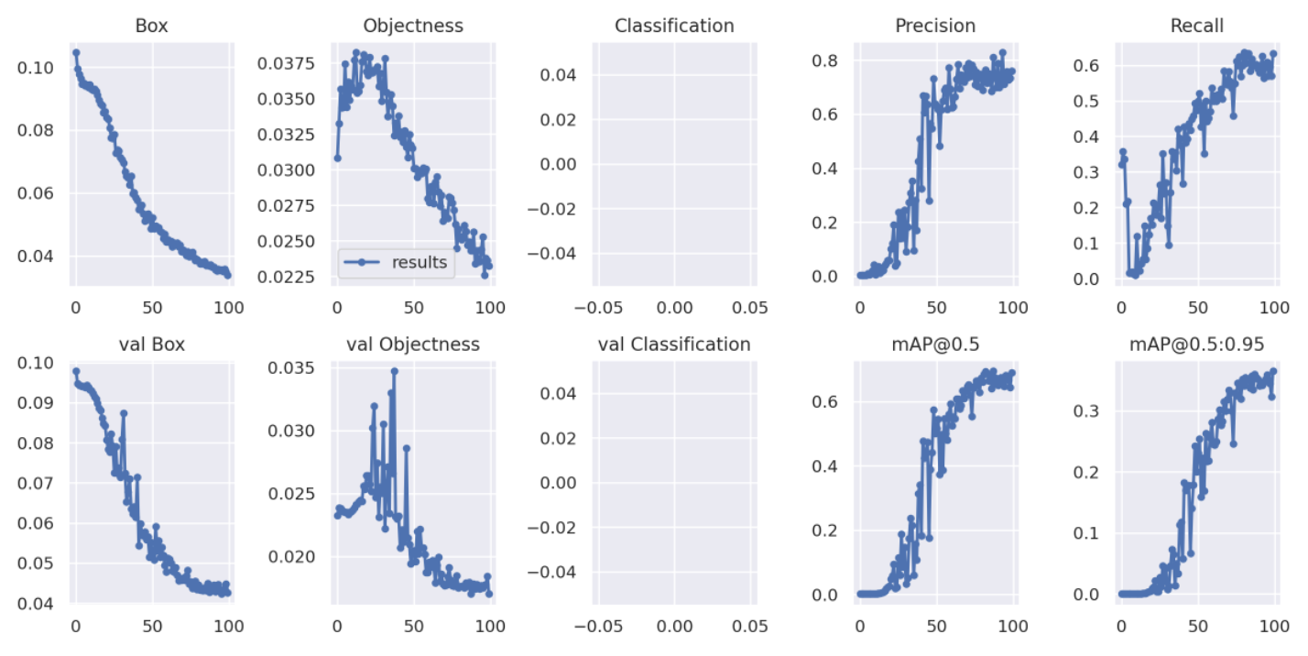
There are various metrics used to measure the accuracy and performance of an object detection model – precision, recall, and mAP at various levels just to name a few. We can even combine these metrics to form a new average metric to judge the performance. But none of these metrics capture the whole picture because, as sometimes judging the performance is a subjective task. However the basic evaluation parameters showed in the above graph can be interpreted as
- mAP at 0.5 IOU shows when there is 50% overlap of bounding box over the pothole the accuracy is approx 65%
- mAP at 0.95 IOU shows when there is 95% overlap of bounding box over the pothole the accuracy is approx 40%
- What proportion of potholes were positively predicted as potholes? Approx 85% (precision)
- What proportion of actual potholes were identified as potholes? Approx 65% (recall)
- The box loss is nearly 0.1 which represents that box identifying the pothole perfectly covers the pothole by locating the center of it
- The object loss is approximately near to 0.02 and might decrease if we run more epochs (~3000), which means that the bounding boxes will more likely to contain potholes

CONCLUSION
No doubt, the model performs satisfiable. However there are some concerns which should be considered for future work
- The size of the dataset is too small, data augmentation steps might be healpful or survey needed to collect more images
- Only 100 epochs were run due to time and space constraints, in future we can increase number of epochs to 3000 to better understand the model performance
- We can amend this model to work on the video dataset to detect potholes on runtime while driving or walking across the road in order to have a safe journey.
REFERENCES
- Comparison between various YOLOv5 models
- Original notebook tutorial provided by ROBOFLOW on how to train Yolov5 on Custom Dataset\

